1. Editing profile – is taking invalid zip codes and dob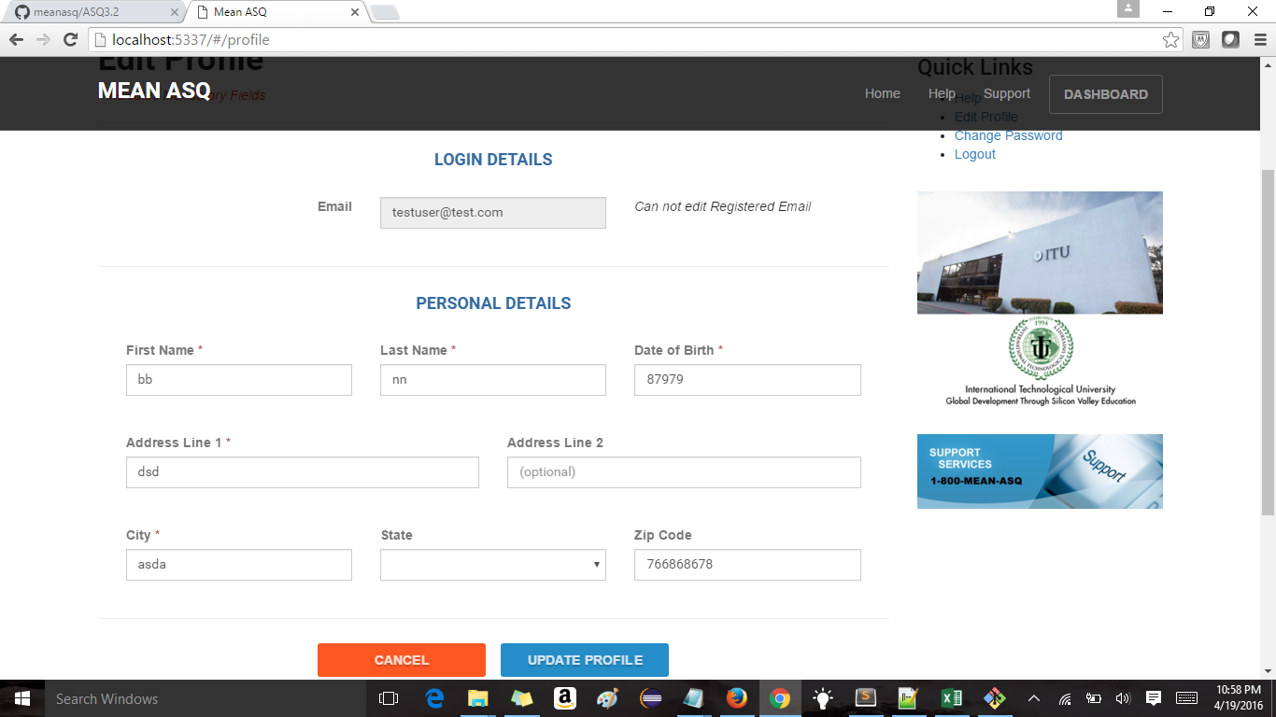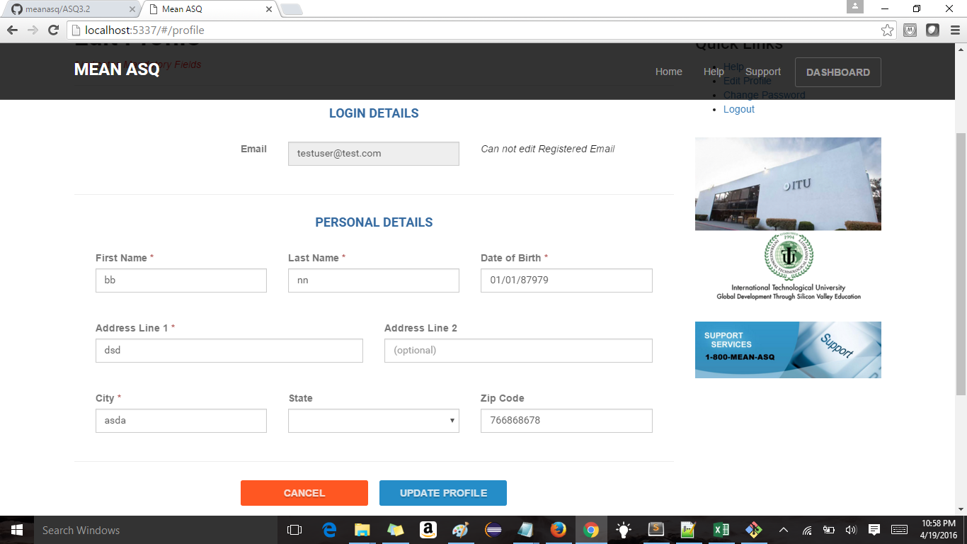
2. When user changes his password he get message “ "Password updated successfully ! Please login using New Password" but he is not logged out
3. When user clicks change password link and only enters old and new password leaving confirm password field blank ideally update password button should be disabled but as its not disabled when you click on the button nothing happens on page
4. User is able to change password with less than 6 characters, mismatch of passwords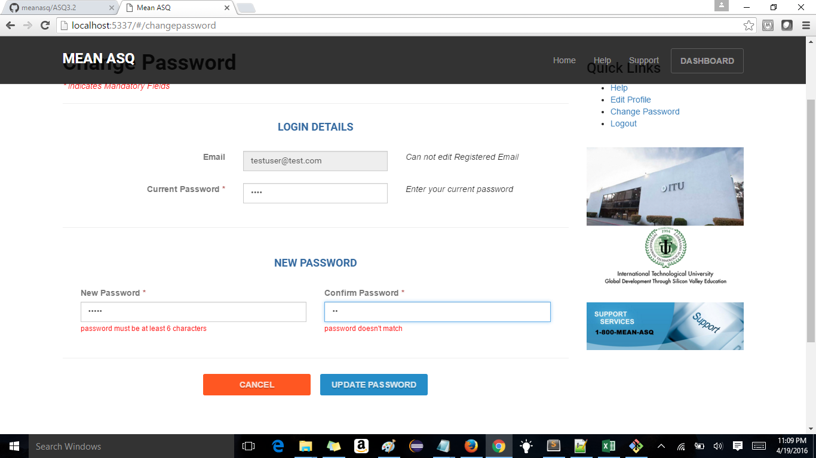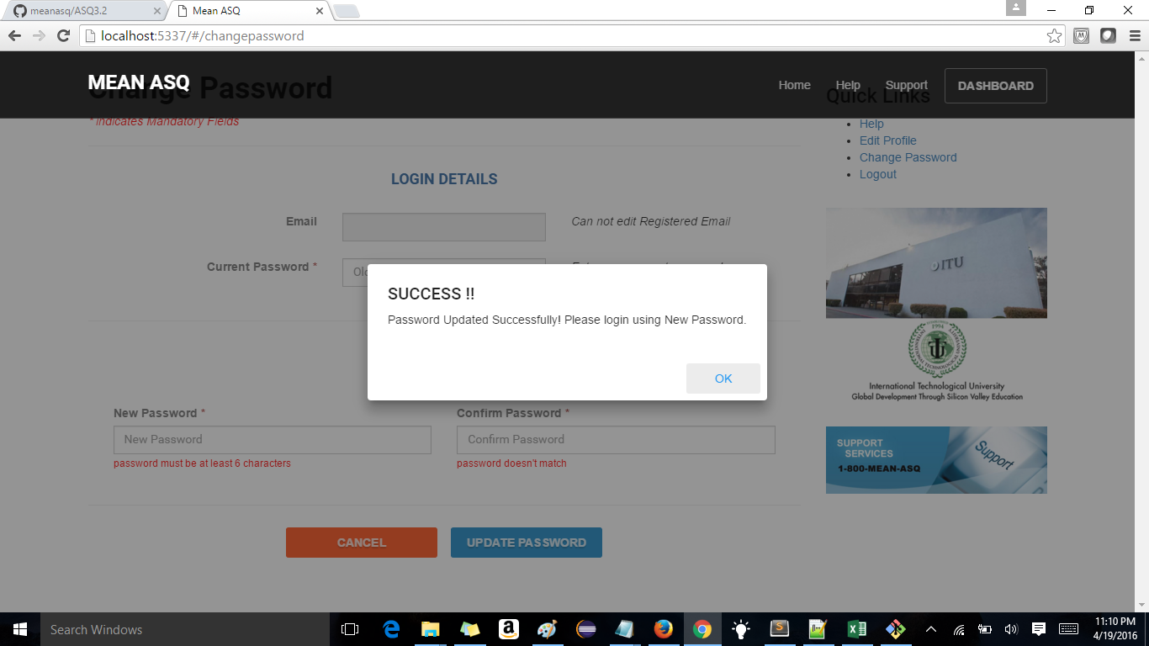
5. Chart settings button is not functioning yet
6. If user doesn’t select any category under practice mode then submit button should be disabled but now its enabled and not doing anything
7. Quit Practice button is not present in Practice mode
8. when I change the expiry date to past date. the user when he tries to login is getting error invalid id and password.When I change the user expiry date to future date and the user tries to login same error is displayed

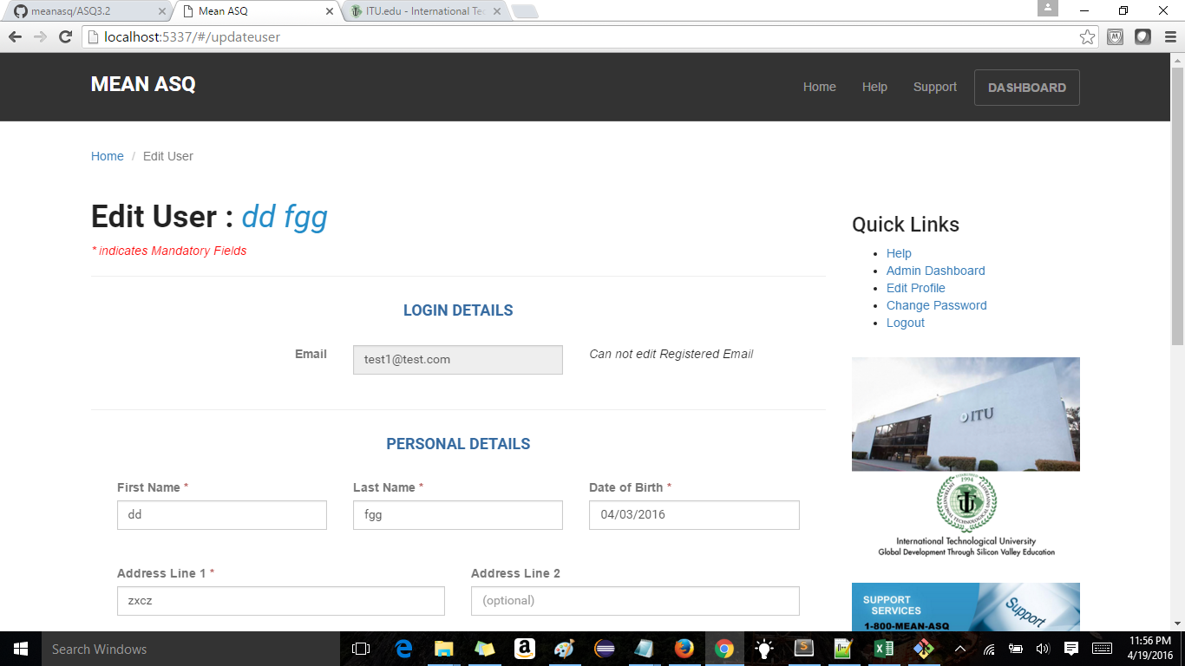

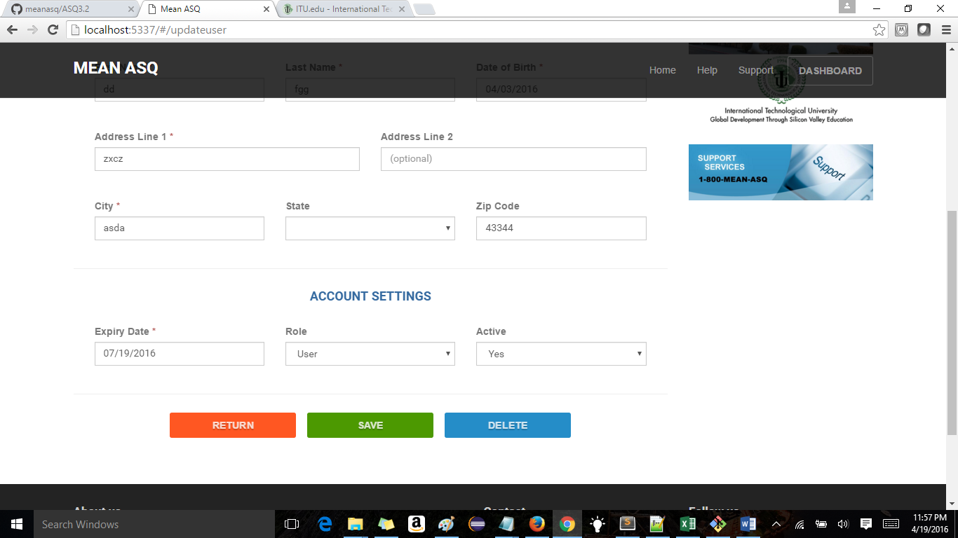

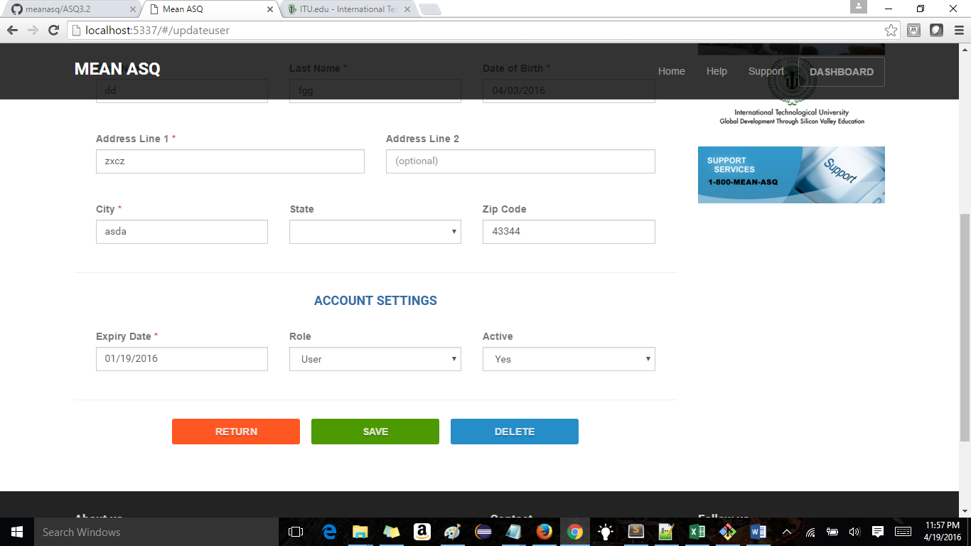

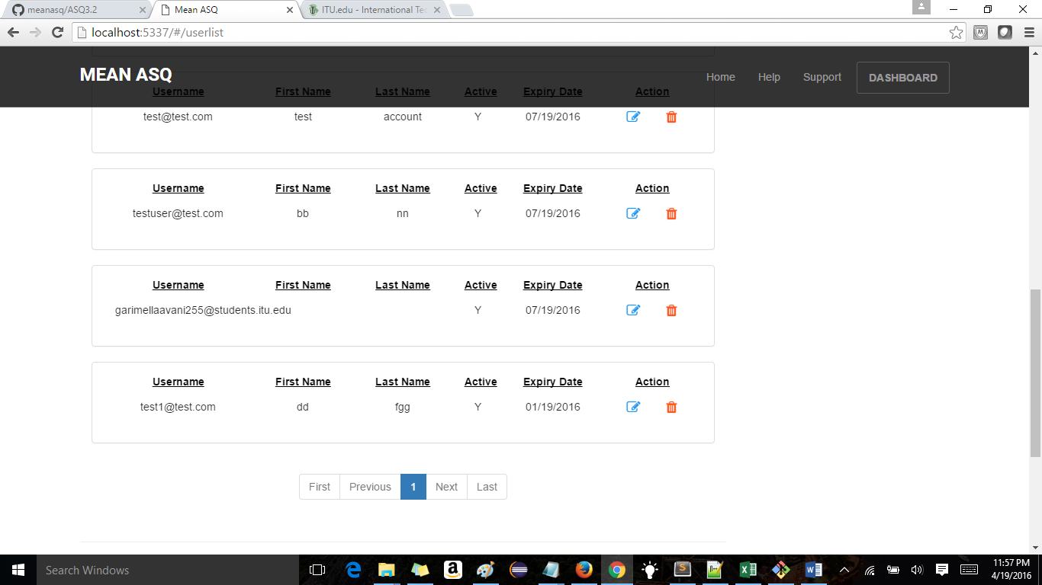

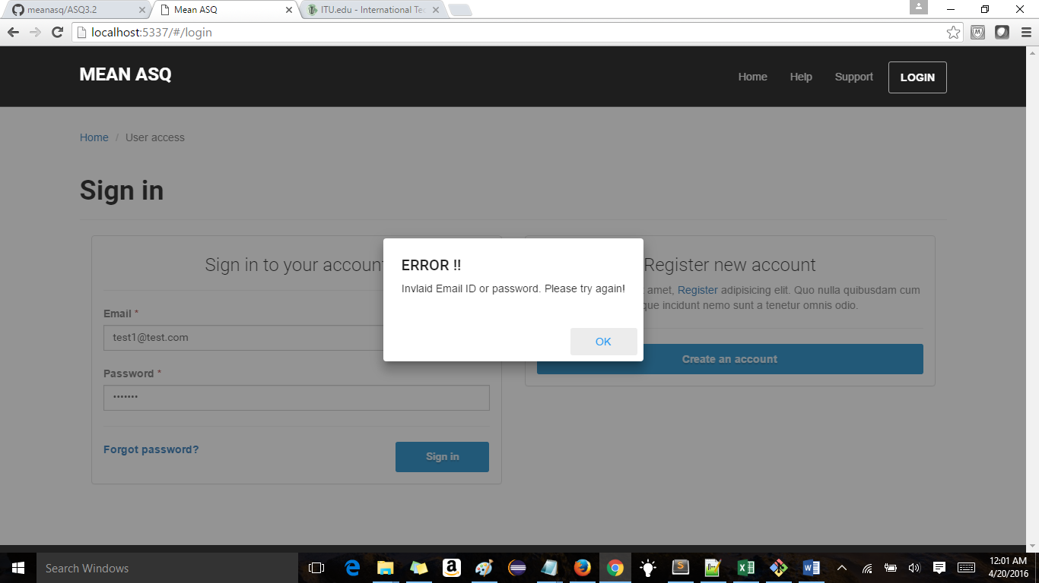

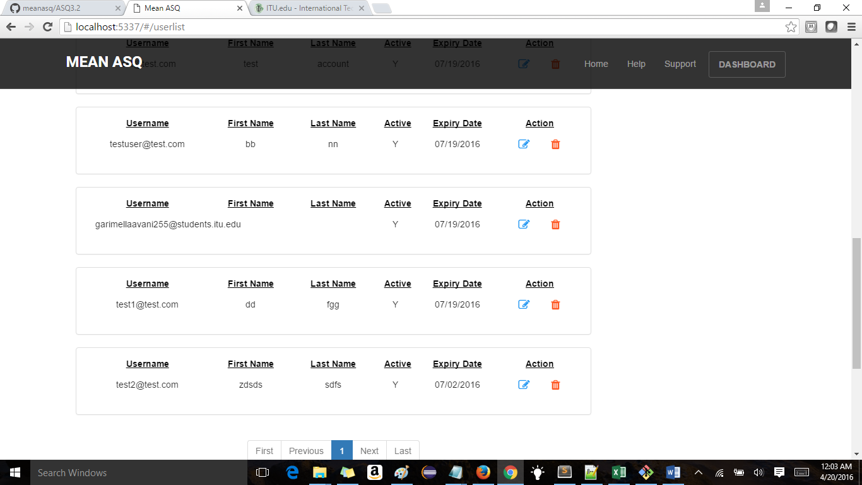



1. Under manage users when admin edits user details he can give invalid zipcode , dob and can leave mandatory fields blank

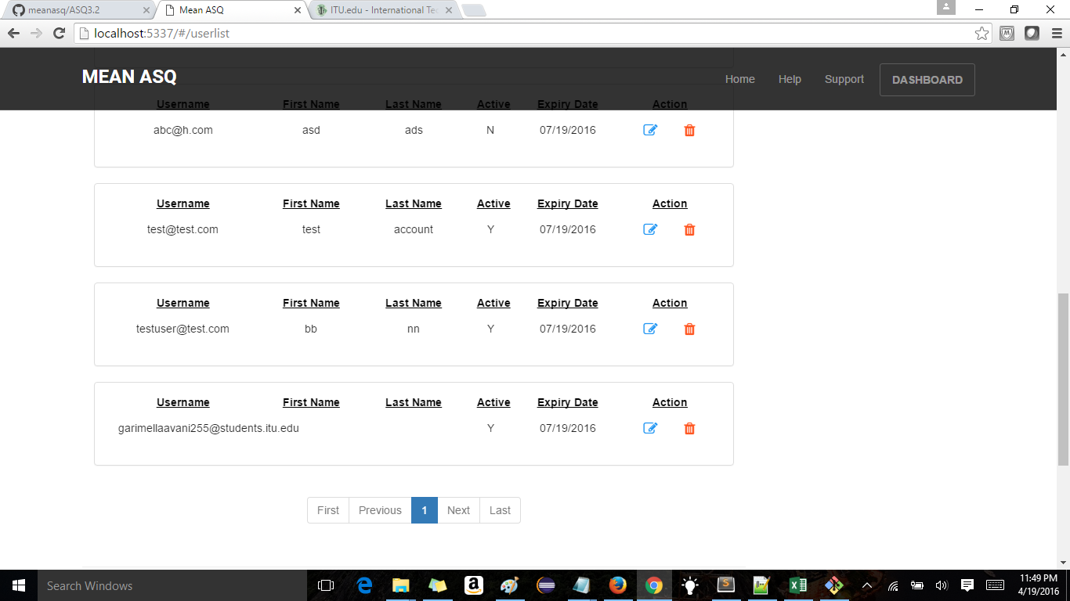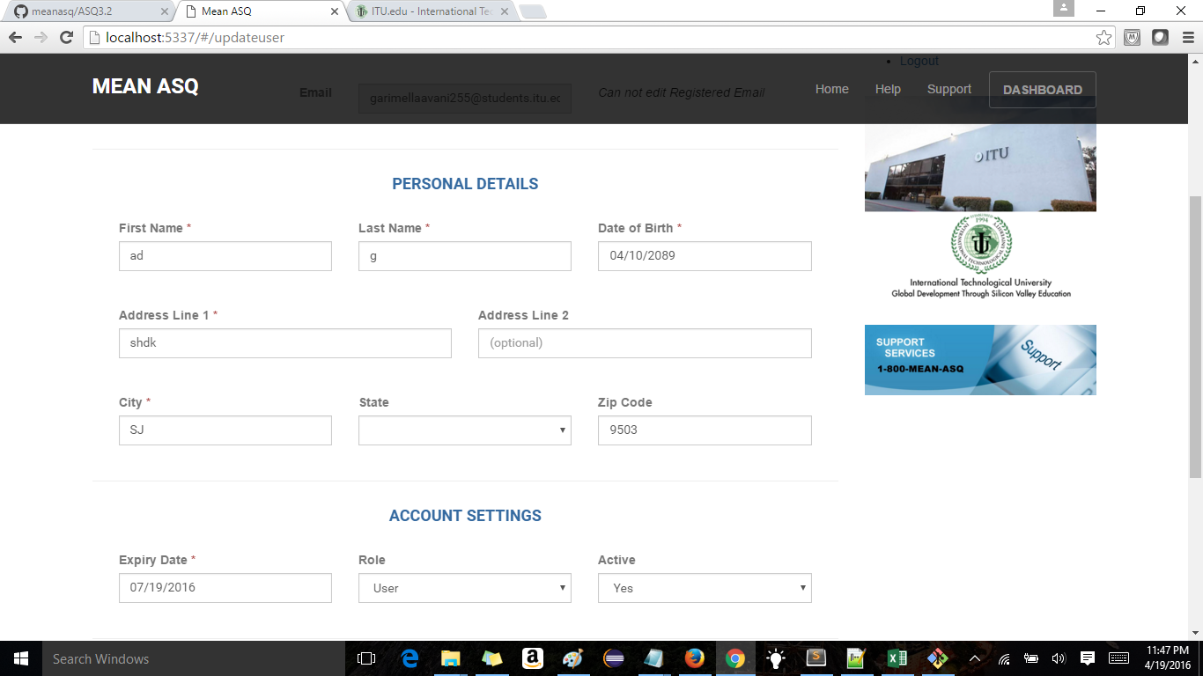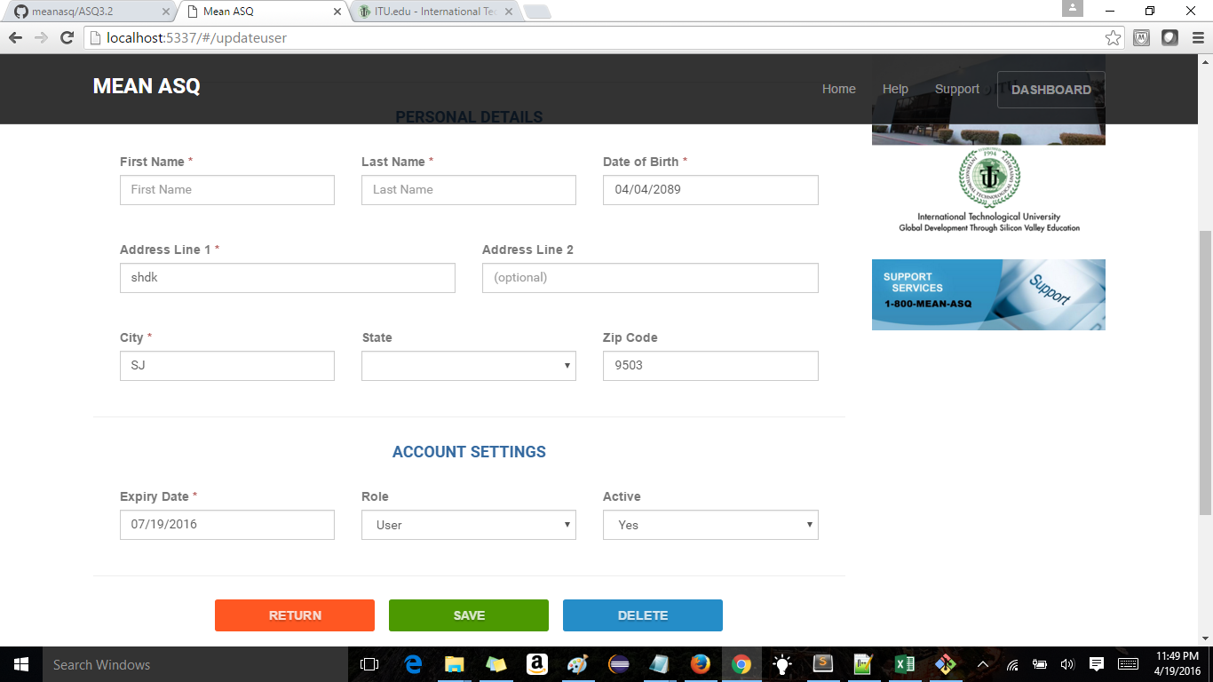

1. Issue with search in manage users. When admin searches with some email id and if its not present it gives message user not found . But there is no option to clear the search so when you click on return it goes to dashboard and after u click on manage users it still throws error message as the search was not cleared. 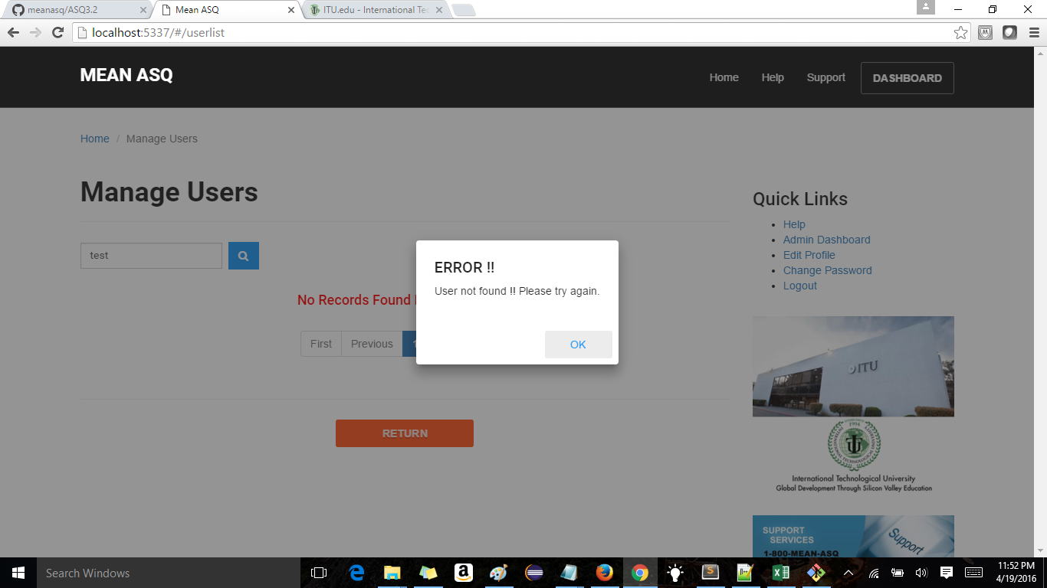
2. Under Question management when you select category and hit search button - momentarily it shows error message no questions available 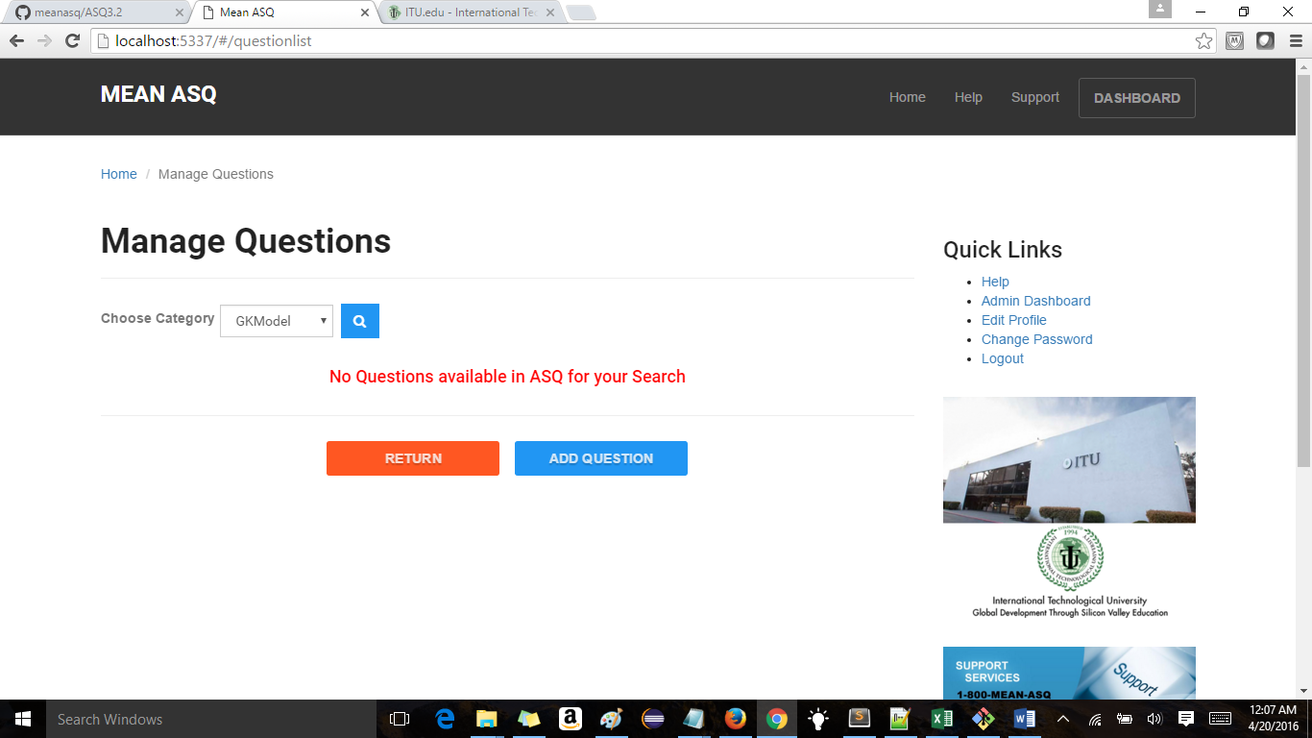
3. Manage Questions- when u delete the question desc and click save button nothing happens (either save should be disabled or throw error message as the mandatory field is left blank)
4. Mange questions – admin can enter any letter apart from ABCD in correct choice. 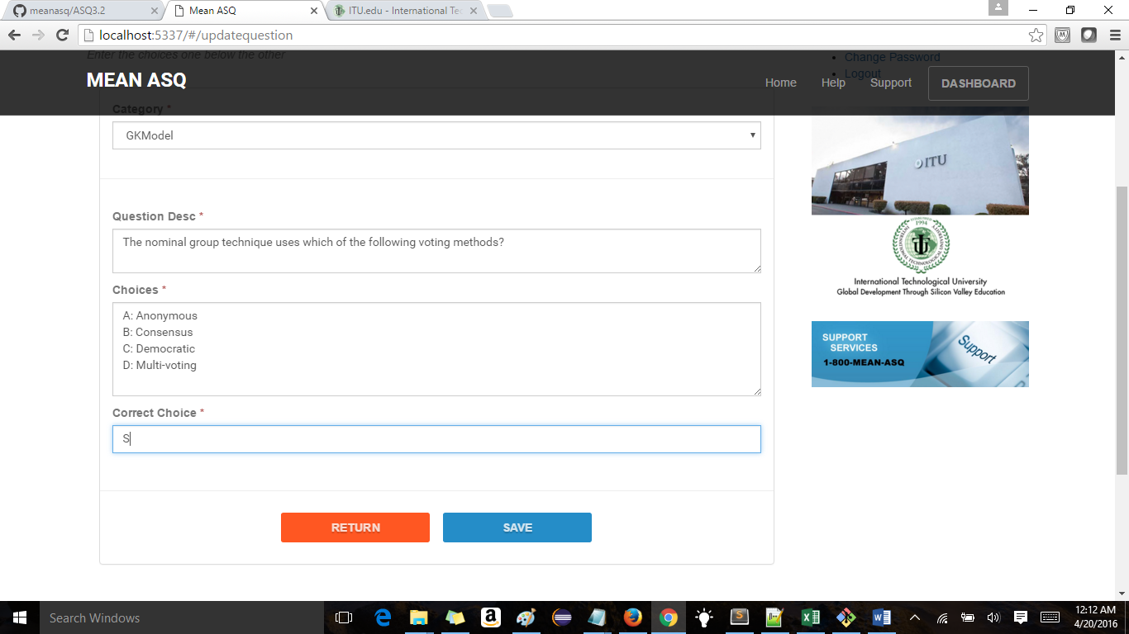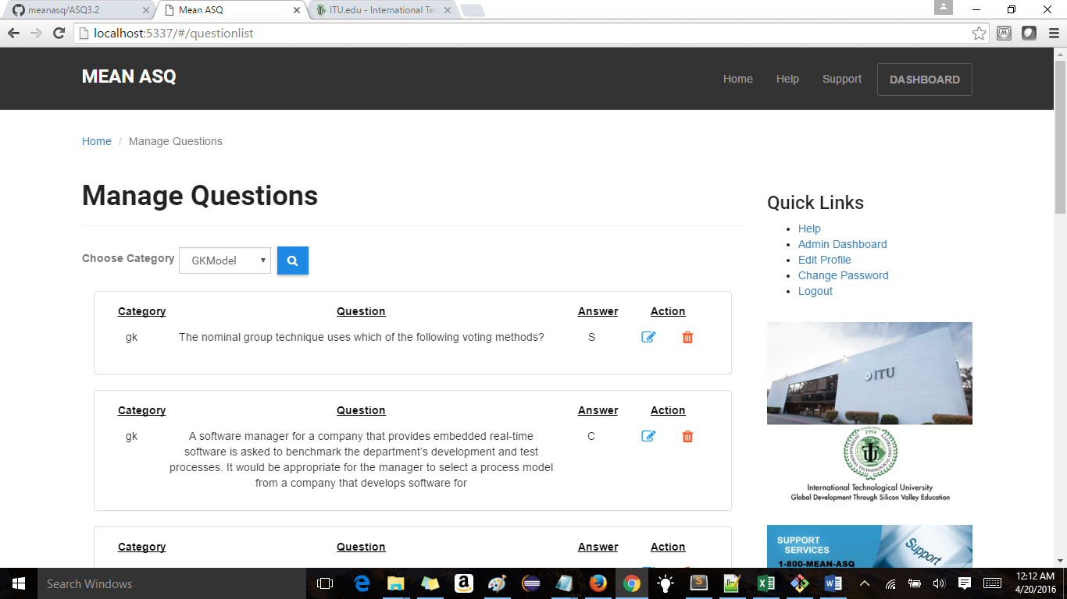
5. Add Question is not function in admin login. That is we are not able to save question .
6. Manage Categories in admin dashboard is not functioning yet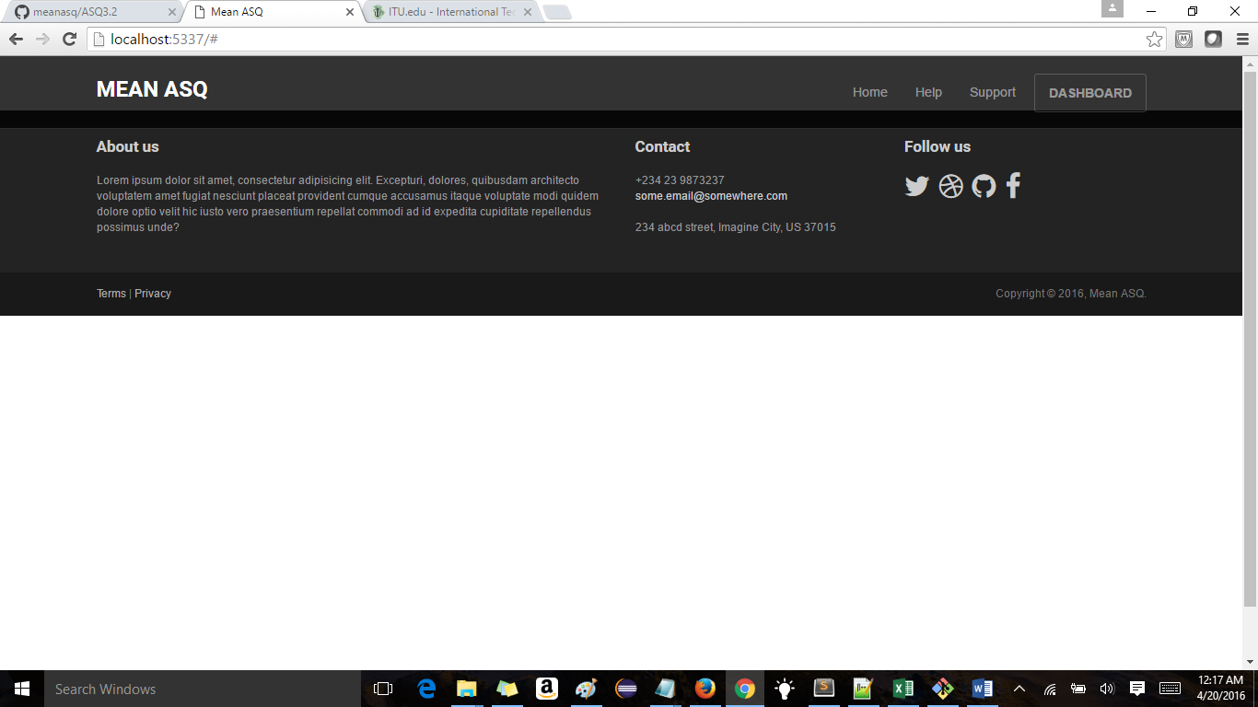
7. What happens in a scenario where you want to edit a question and you change the category to different category and click save button(for now nothing is happening)